Фильтр по 2022

1-2
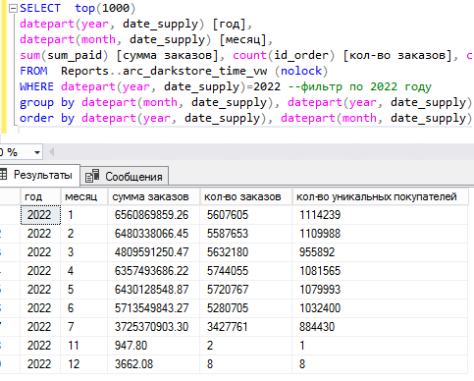

SELECT top(1000)
datepart(year, date_supply) [год],
datepart(month, date_supply) [месяц],
sum(sum_paid) [сумма заказов], count(id_order) [кол-во заказов], count(distinct number) [кол-во уникальных покупателей]
FROM Reports..arc_darkstore_time_vw (nolock)
WHERE datepart(year, date_supply)=2022 --фильтр по 2022 году
And datepart(month, date_supply)<10
group by datepart(month, date_supply), datepart(year, date_supply)
order by datepart(year, date_supply), datepart(month, date_supply)
1-1
SELECT top(1000)
datepart(year, date_supply) [год],
datepart(month, date_supply) [месяц],
sum(sum_paid) [сумма заказов], count(id_order) [кол-во заказов], count(distinct number) [кол-во уникальных покупателей]
FROM Reports..darkstore_time_vw (nolock)
WHERE datepart(year, date_supply)=2022 --фильтр по 2022 году
group by datepart(month, date_supply), datepart(year, date_supply)
order by datepart(year, date_supply), datepart(month, date_supply)

2-1
select top(1000)
datepart(year,closedate) [год] ,
datepart(month,closedate) [месяц] ,
sum(Basesum) [сумма заказов]
from sms_union..checks (nolock)
where order_id is not null
group by datepart(year,closedate), datepart(month,closedate)
2-2
select top(1000)
datepart(year,closedate) [год] ,
datepart(month,closedate) [месяц] ,
sum(Basesum) [сумма заказов]
from sms_izbenka_arc..su_checks (nolock)
where order_id is not null and datepart(year,closedate)=2022
group by datepart(year,closedate), datepart(month,closedate)

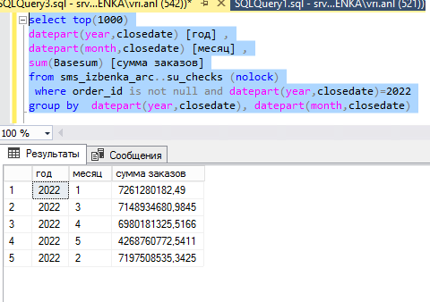
3-1
В третьем и так стоит 2022

По месяцам

select top(1000)
datepart(year,closedate) [год] ,
datepart(month,closedate) [месяц] ,
sum(Basesum) [сумма заказов]
from SMS_IZBENKA_ARC..su_Checks (nolock) --архив для данных с начала года
where order_id is not null and datepart(year,closedate) = 2022
group by datepart(year,closedate), datepart(month,closedate)

4
select top(1000)
datepart(YEAR, date_supply),
datepart(month, date_supply),
[сумма заказов] = sum( case when order_type = 2 and source not in (36, 38, 50, 58,53,57) then isnull(sum_closed, sum_paid + sum_paid_coupon) else sum_collected end),
[покупатели] = count(distinct number) ,
count(id_order) [заказы]
FROM Loyalty03..orders_header oh (nolock) --если архив Loyalty_srv03..arc_orders_header oh (nolock)
WHERE datepart(YEAR, date_supply)=2022 --за 2022
group by datepart(month, date_supply),datepart(YEAR, date_supply)

5-1 и так 2022.
select datepart(year,closedate) [год] ,
datepart(month,closedate) [месяц] ,
sum(Basesum) [сумма заказов "на завтра"]
from sms_union..checks (nolock) ch
INNER JOIN Reports..darkstore_time_vw (nolock) vw ON vw.id_order=ch.order_id
where order_id is not null and datediff(day, date_order, date_supply) = 1
group by datepart(year,closedate), datepart(month,closedate)

